**Login Page:**

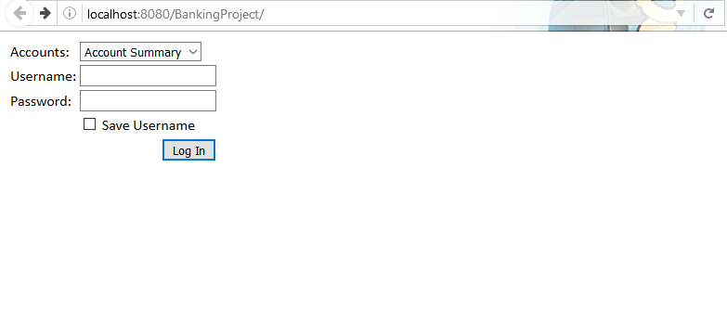

**If username and password are empty then:**

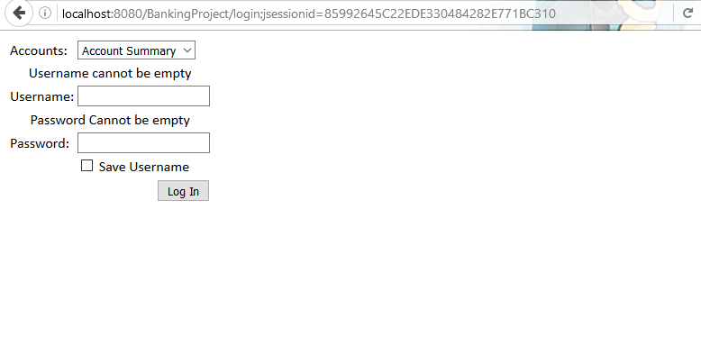

If we put select Account Summary in the drop down list then it’ll redirect to Account Summary after logging in and if we select Transfers page it’ll go to transfers page after successfully logging in.

We can select Save Username, where the cookie will stored only for one day.

**Account Summary:**

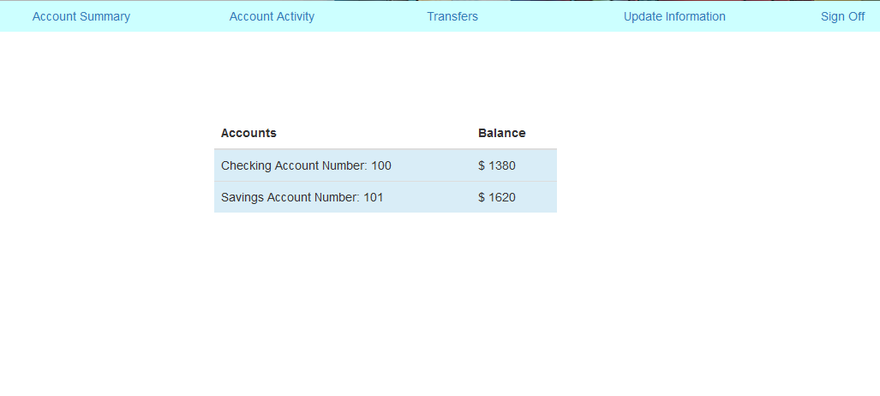

**Account Activity:**

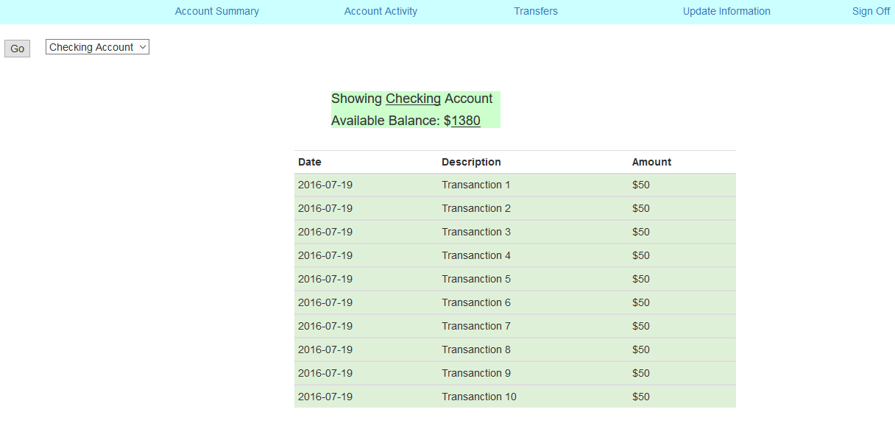

We can **navigate between savings and checking account** and all the requests are handled using **jQuery AJAX**, which means the loads without reloading the page.

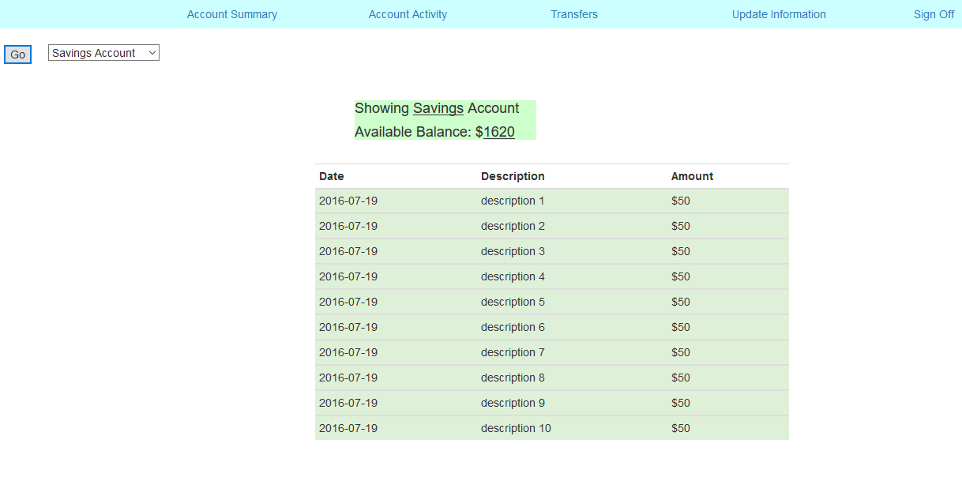

**Transfers Page:**

We can transfer money between our two accounts.

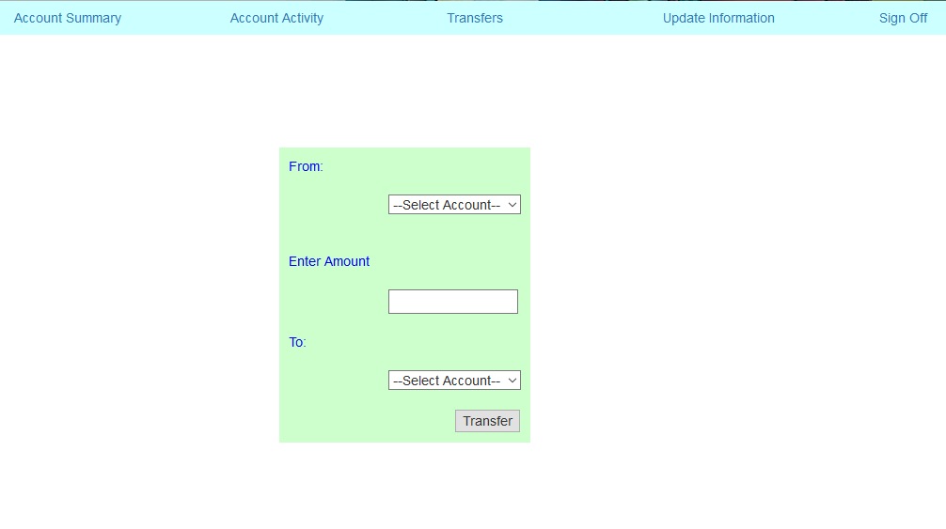

**Update Information:**

When we click on this page all our recent information will be populated in their respective fields, we need to edit and click update to update the information.

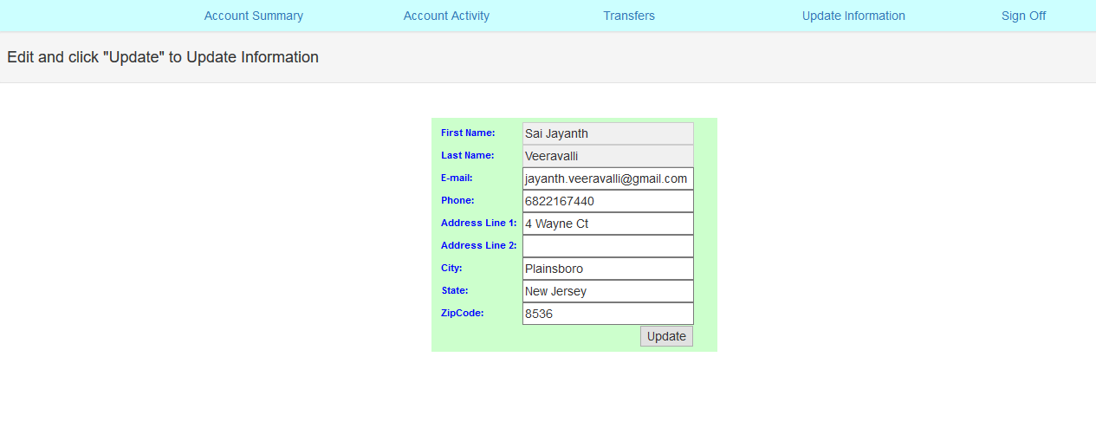

And finally **Sign off** which will **redirect to login page**.